**PROJECT REPORT**

**CSE2004: DATABASE MANAGEMENT SYSTEM**

**FOOTBALL LEAGUE MANAGEMENT SYSTEM**

**ROCHAK SHRIVASTAV 20BCE1814**

**HARSH DHAMU 20BPS1059**

**SURVARAM RISHABH REDDY 20BCE1545**

***B. Tech in Computer Science and Engineering***

**Faculty**

**Dr. S A Sajidha**



**VIT CHENNAI**

**TABLE OF CONTENTS**

|  |  |  |
| --- | --- | --- |
|  | Topic | Page no. |
| 1. | Introduction |  |
| 2. | Abstract |  |
| 3. | Objective |  |
| 4. | ER Model |  |
| 5. | Software used |  |
| 6. | Database connectivity steps |  |
| 7. | Modules |  |
| 8. | Working of each module |  |
| 9. | Challenges |  |
| 10. | Conclusion |  |

**INTRODUCTION:**

Football is one of the most popular sport these days and is enjoyed by a large number of people. Every year different football leagues and competitions take place, and a management system is required for data handling which contains the details of all the players and their teams, the league schedule and the various achievements of different players. Thus, a system which not only displays and modifies the information but also presents it in a good manner.

**ABSTRACT:**

Football league management system is a system that will be used to manage football competition. Basically, the system is designed such that it will suit the basic required information of players of different teams and the requirements of league. The system will be developed using NetBeans IDE and MySQL. It will focus on storing the entire information from start of league to storing information of the various records achieved by players to the outcome of matches till the tournament is over. Currently most of the organizations are using the filing method to store and manage all the information during the tournament period. The filing method gives a few complications for staff to handle al that data. The system that is developed will provide a complete systematic system which will maintain all the tournament data and come over with favourable reports. Therefore, all the jobs during the tournament took part will become easier and manageable.

**SOCIAL NECESSITY OF THE PROJECT:**

There are different types of data for every player in a team like their position in the team, total number of goals scored by them, successful penalty kicks taken by them, total number of matches played by them, schedule of a league and the outcome of each and every match. This data is difficult to handle using files and highly redundant and inconsistent. Thus, there is a need of system using which these types of information can be easily accessed and also, it can be modified providing its user a seamless experience and making jobs related to this easy.

**WORKFLOW OF THE PROJECT:**

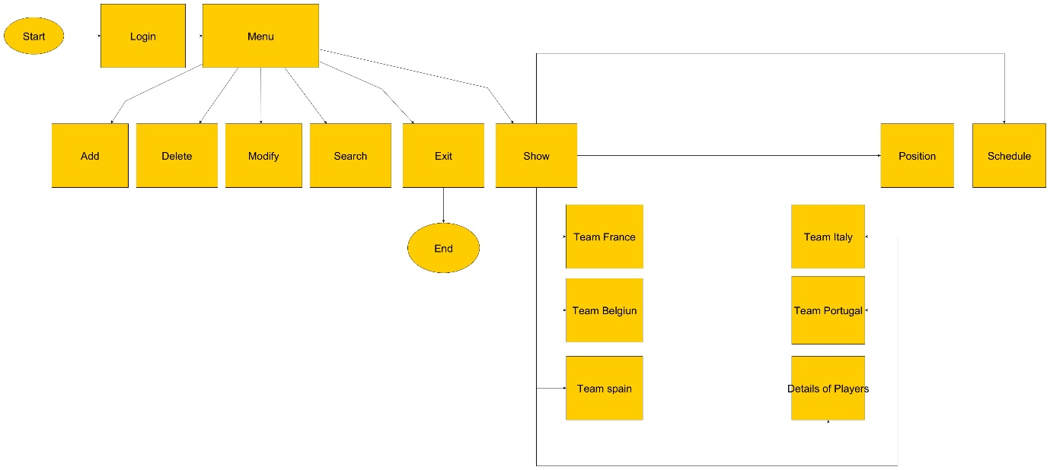

**ER MODEL:**

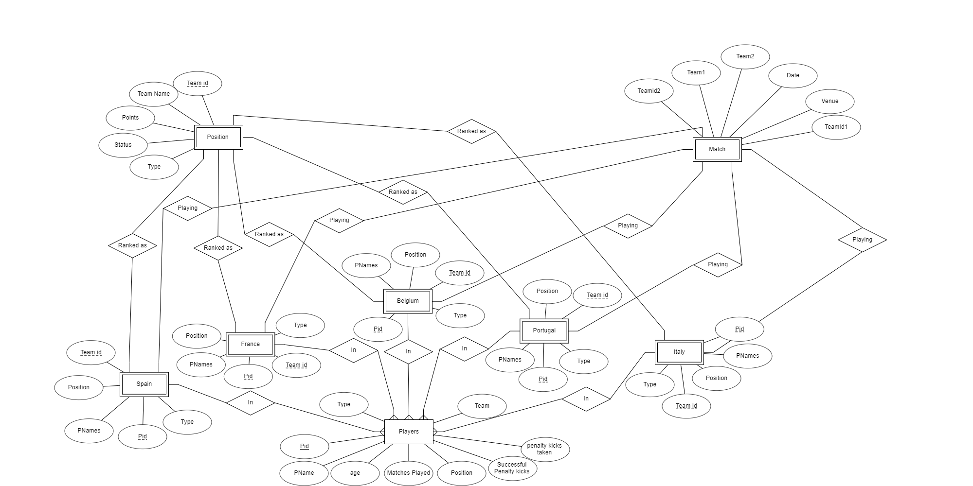

**LIST OF MODULES/ ALGORITHM:**

1. Start
2. Login
3. Menu
4. Add players
5. Delete players
6. Search player details
7. Modify player details
8. Team Spain
9. Team Portugal
10. Team France
11. Team Belgium
12. Team Italy
13. Schedule
14. Position
15. Details of all players
16. Exit

**WORKING OF MODULES/ ALGORITHM:**

**START**

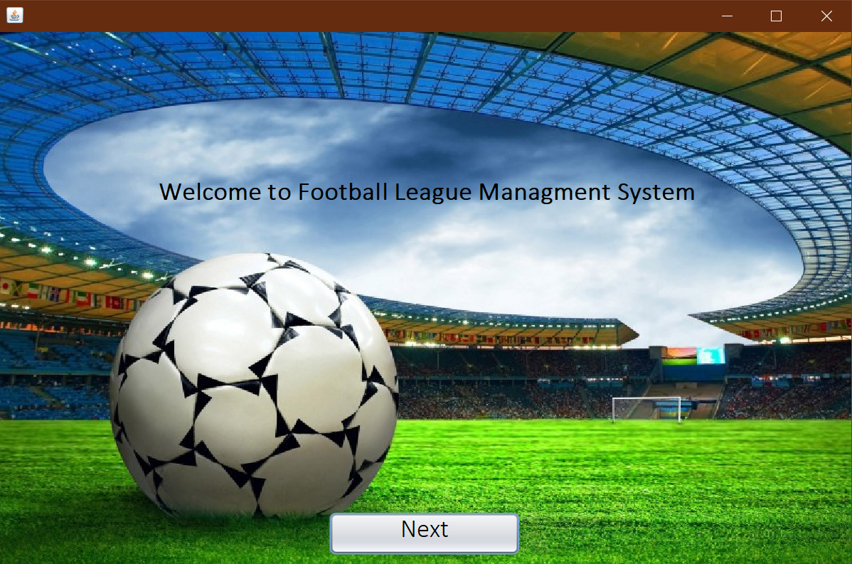

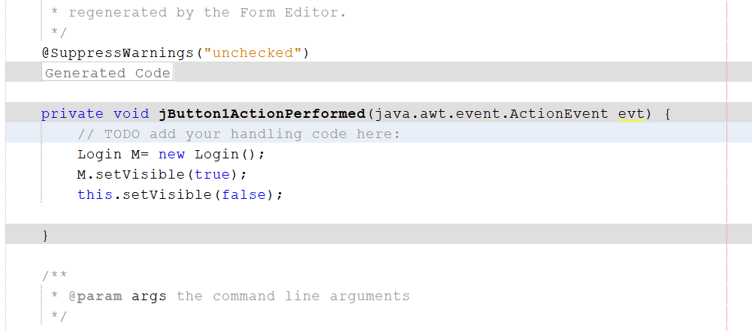

When the software is executed the adjacent frame is visible and the above code is executed and login page is visible as soon as we press the next button.

**LOGIN**

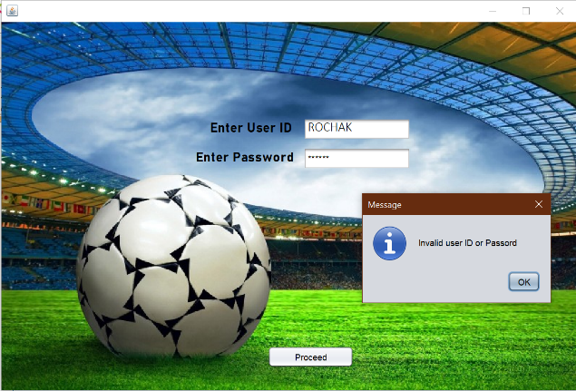When the frame is opened the adjacent code which checks the userid and password entered by user if is correct it navigates him/her to menu else displays a dialogue box as shown below

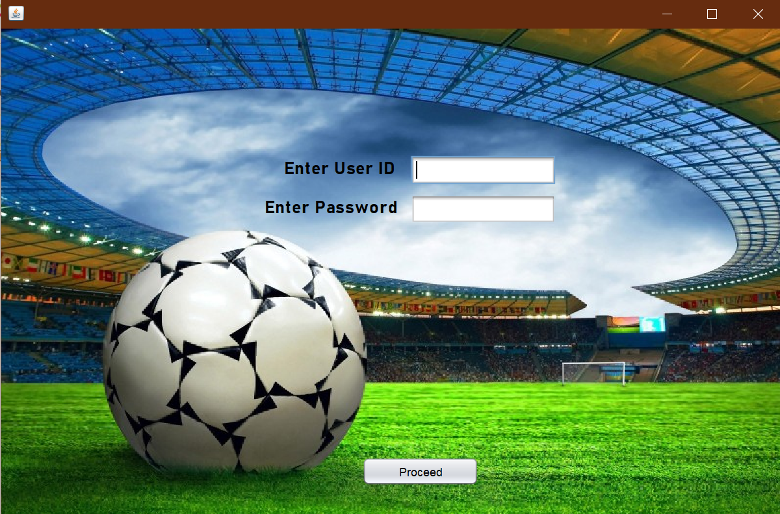

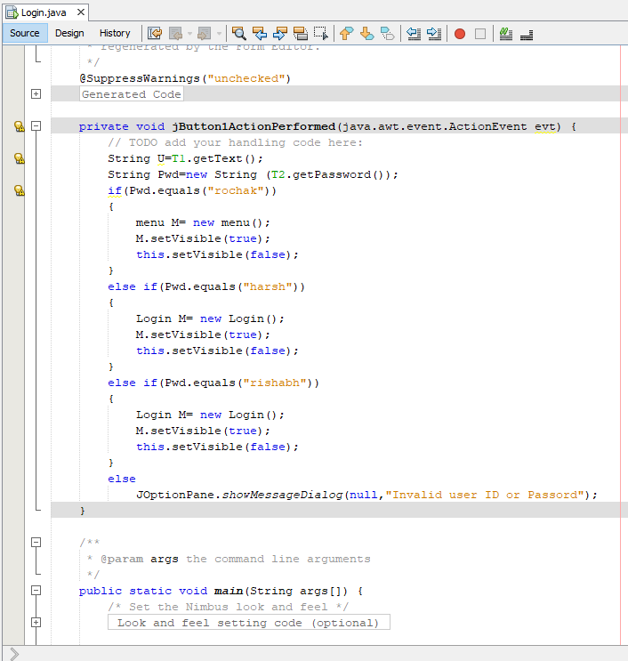

**MENU**

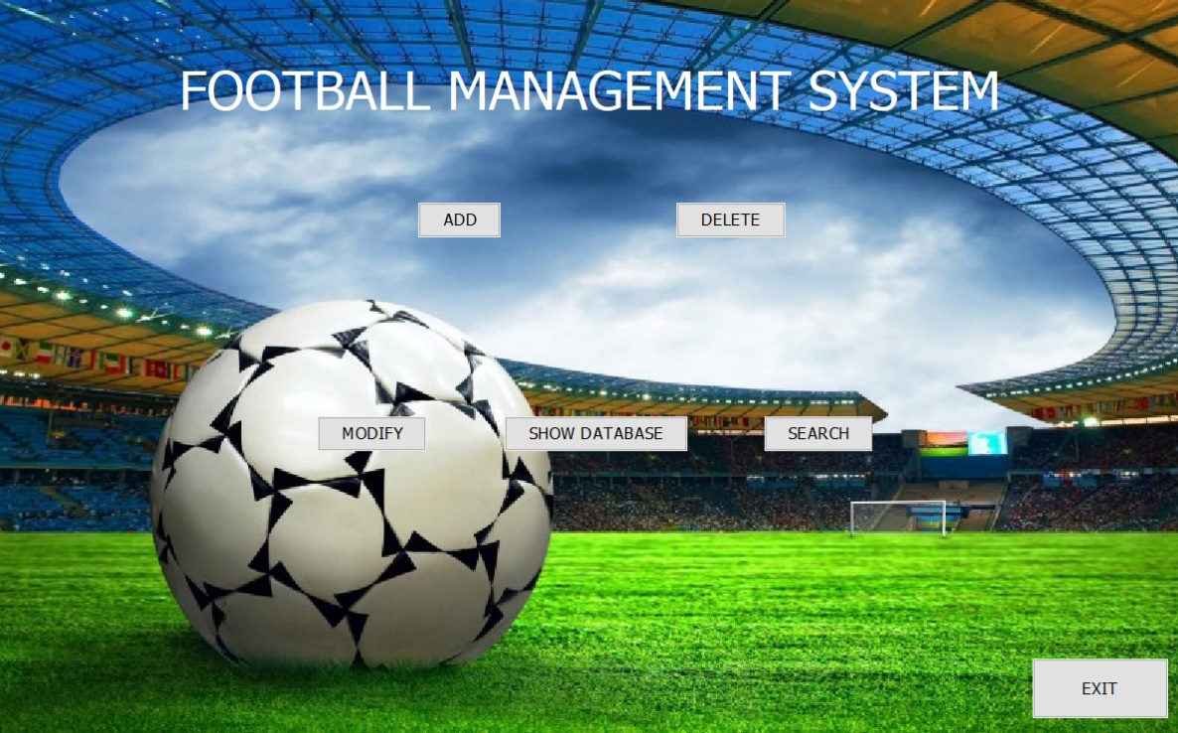

When the frame is opened the below code is executed for respective buttons and it navigates us to different frames.

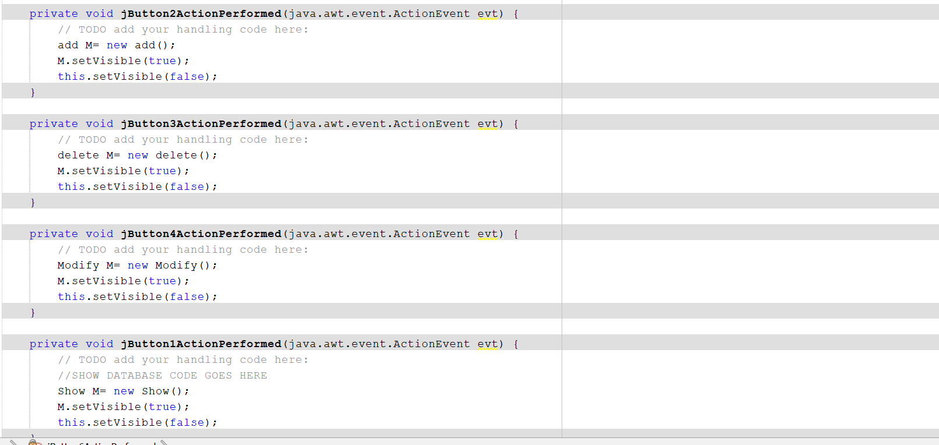

**SHOW**

When the frame is opened the adjacent code navigates user to other frames based on the choice of the user for the button they pressed.

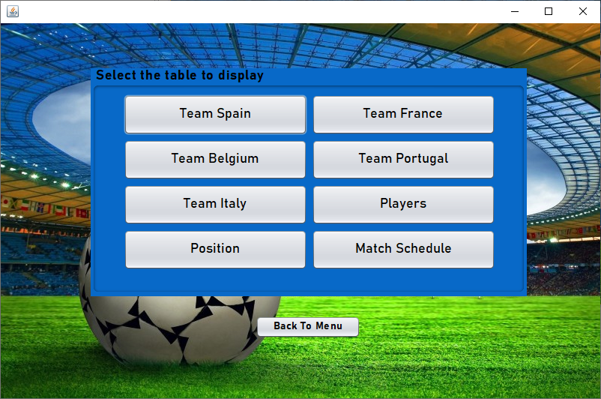

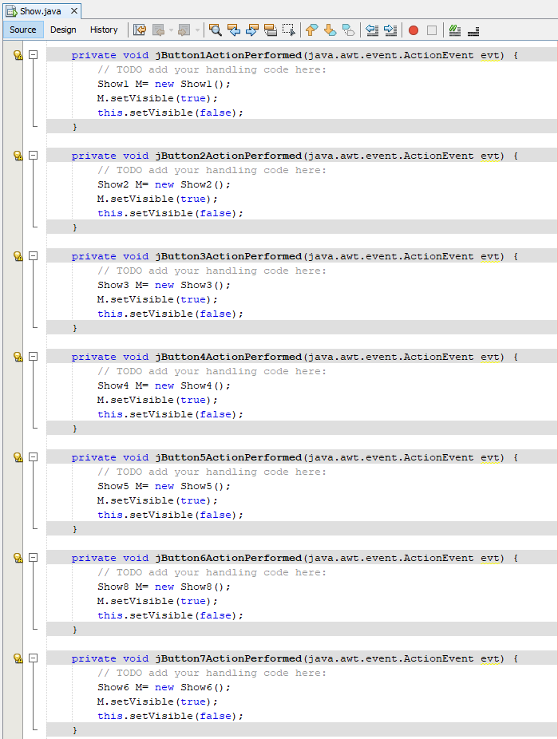

**TEAM SPAIN**

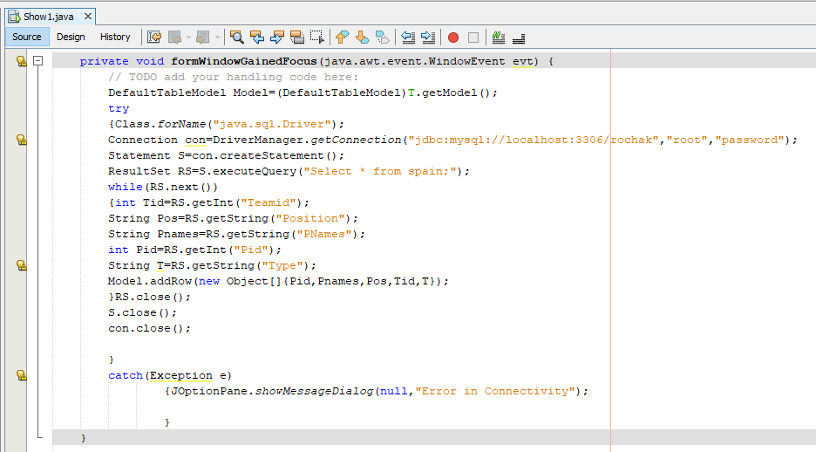

When the frame is opened the above code automatically executed and the frame shown below is displayed.

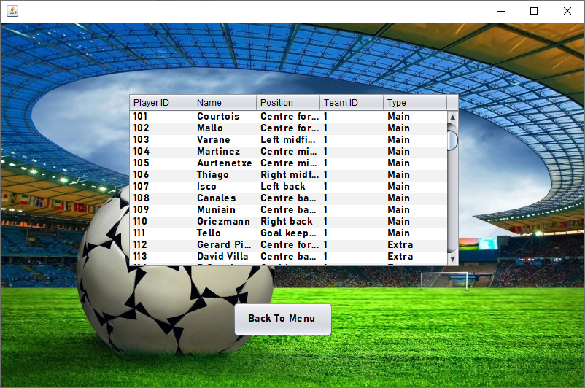

**TEAM FRANCE**

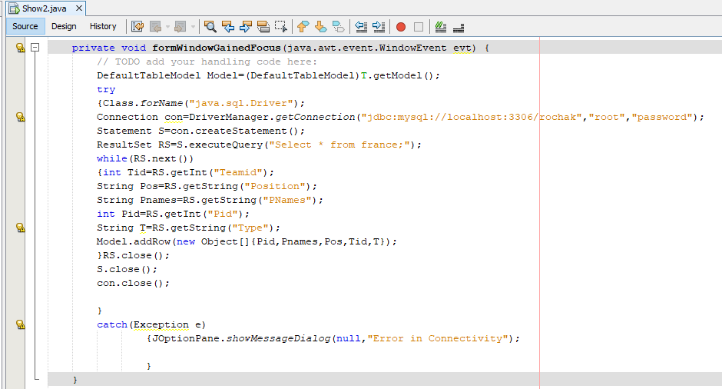

When the frame is opened the above code automatically executed and the frame shown below is displayed.

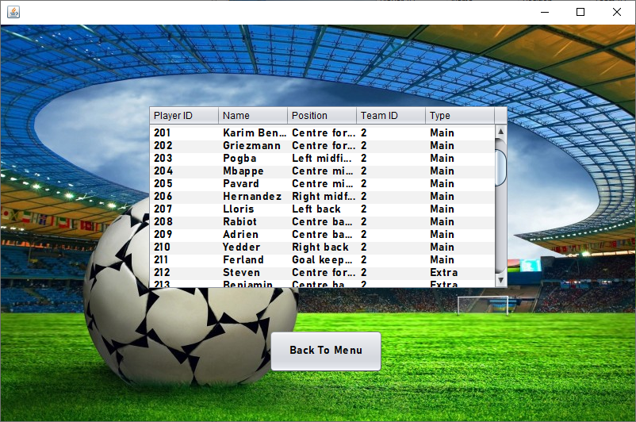

**TEAM BELGIUM**

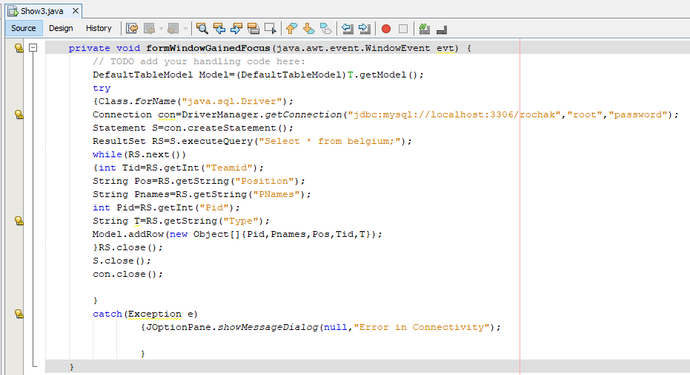

When the frame is opened the above code automatically executed and the frame shown below is displayed.

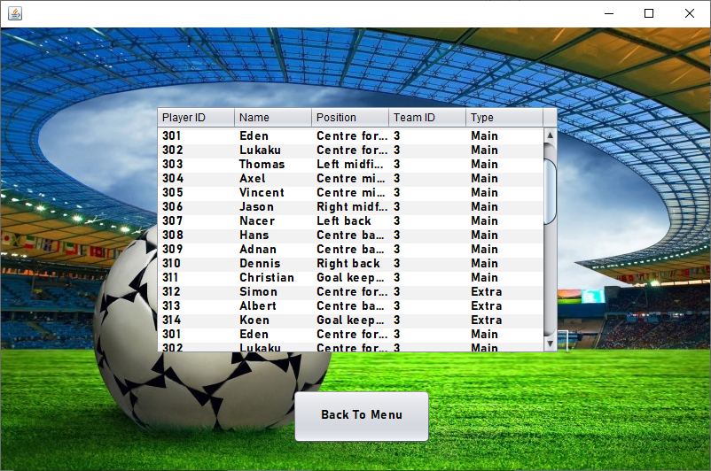

**TEAM PORTUGAL**

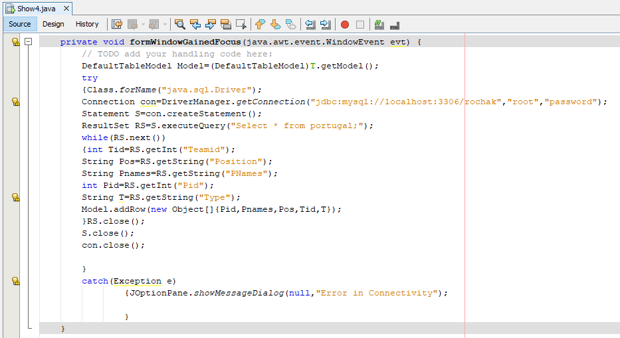

When the frame is opened the above code automatically executed and the frame shown below is displayed.

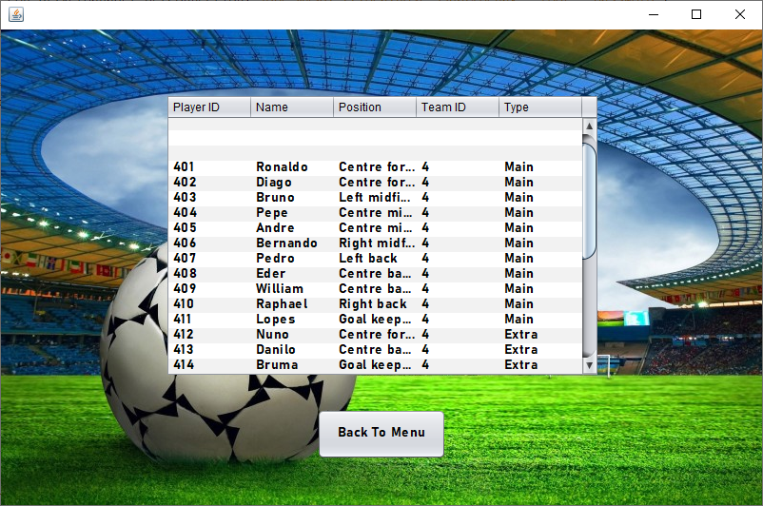

**TEAM ITALY**

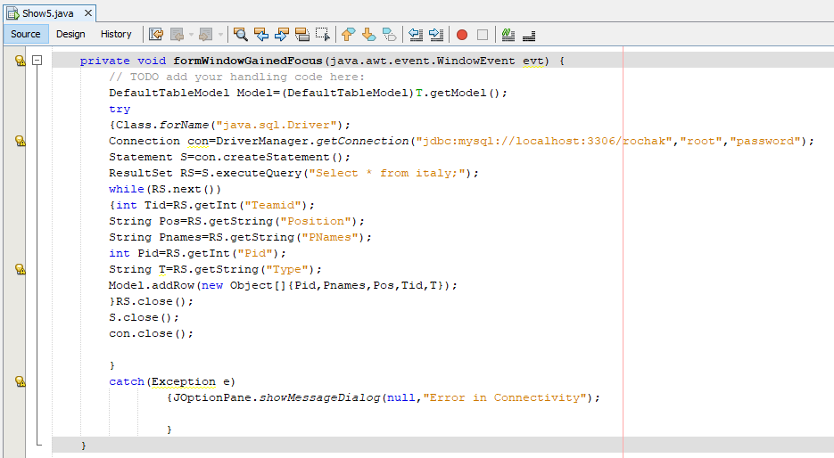

When the frame is opened the above code automatically executed and the frame shown below is displayed.

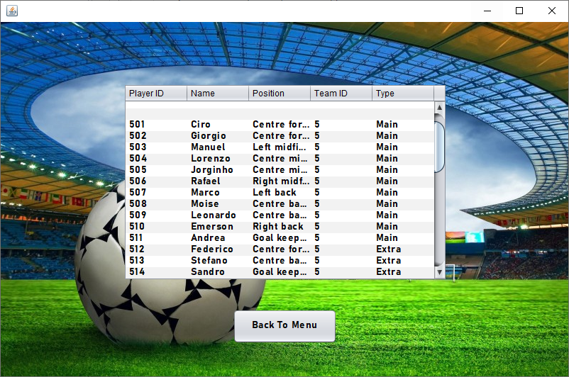

**PLAYERS**

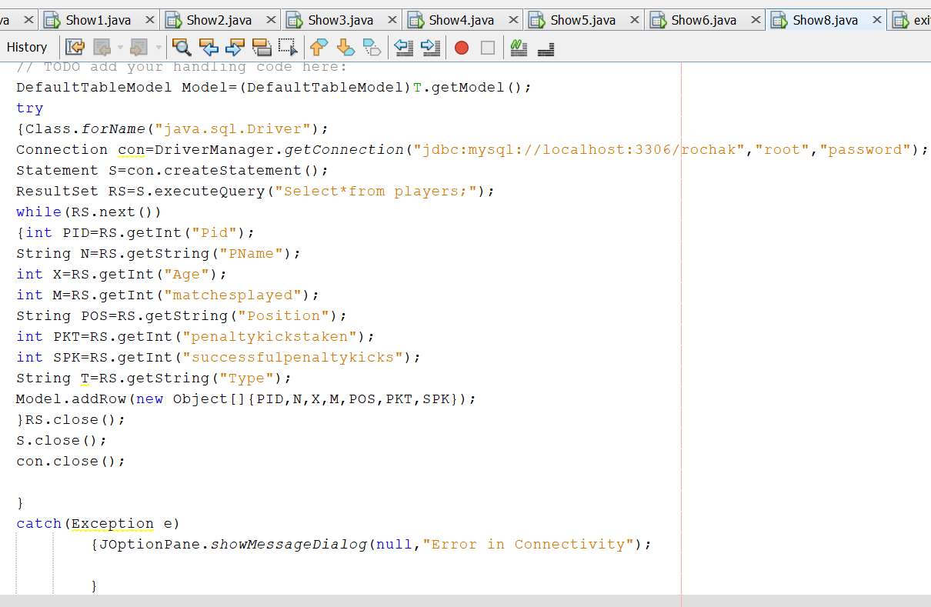

When the frame is opened the above code automatically executed and the frame shown below is displayed.

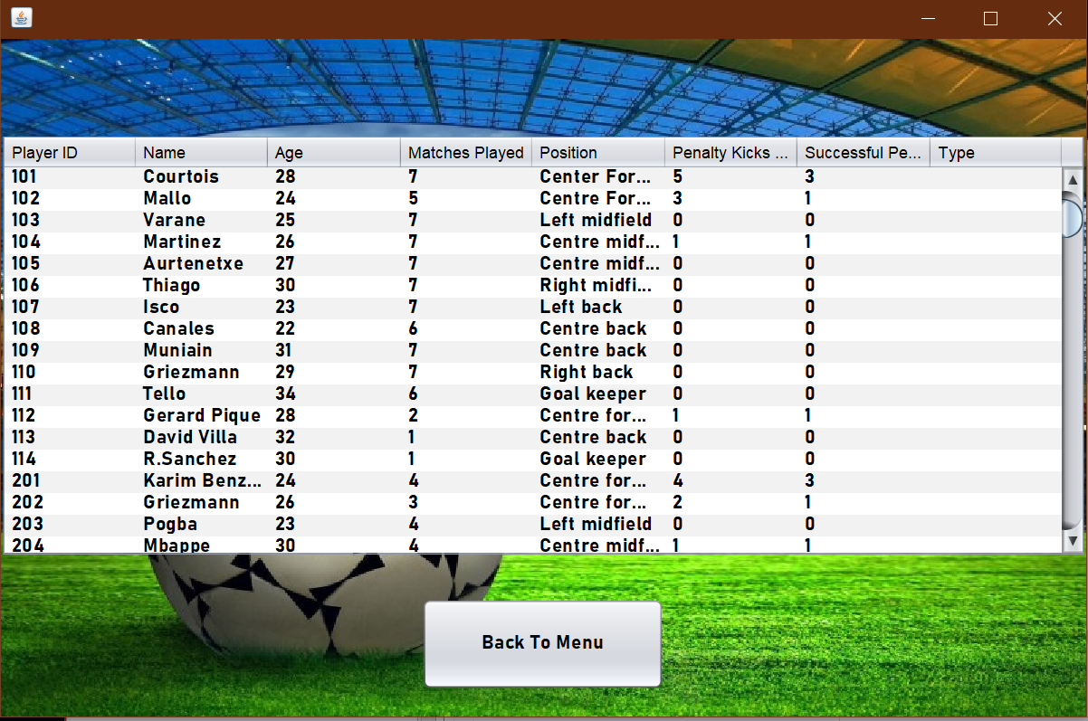

**POSITION**

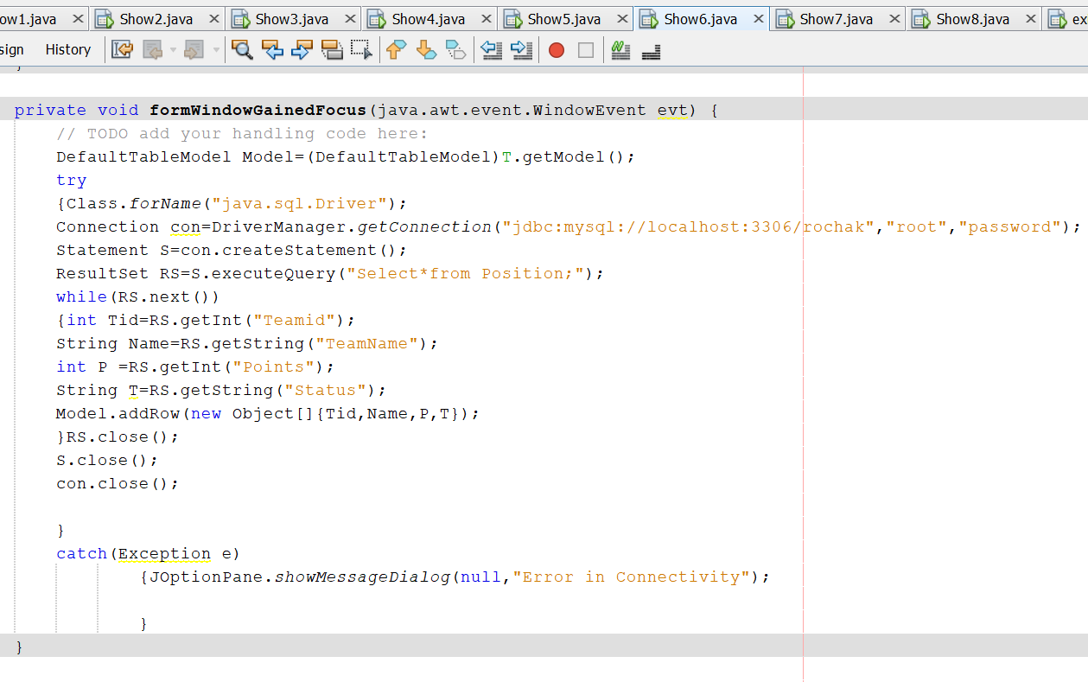

When the frame is opened the above code automatically executed and the frame shown below is displayed.

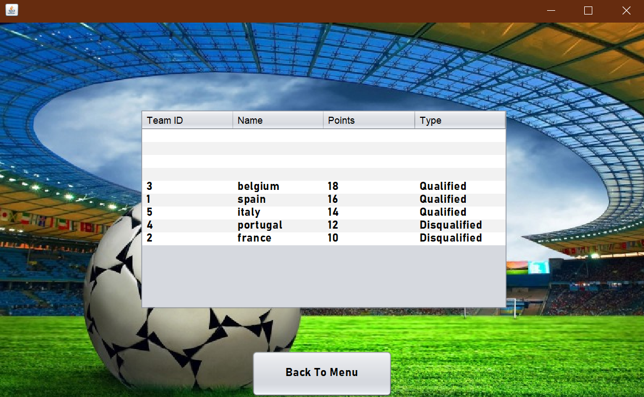

**SCHEDULE**

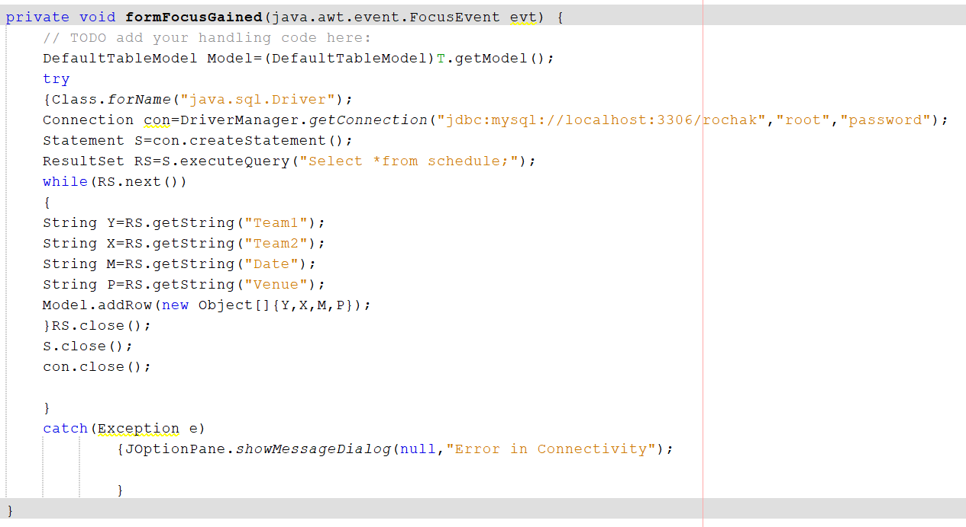

When the frame is opened the above code automatically executed and the frame shown below is displayed.

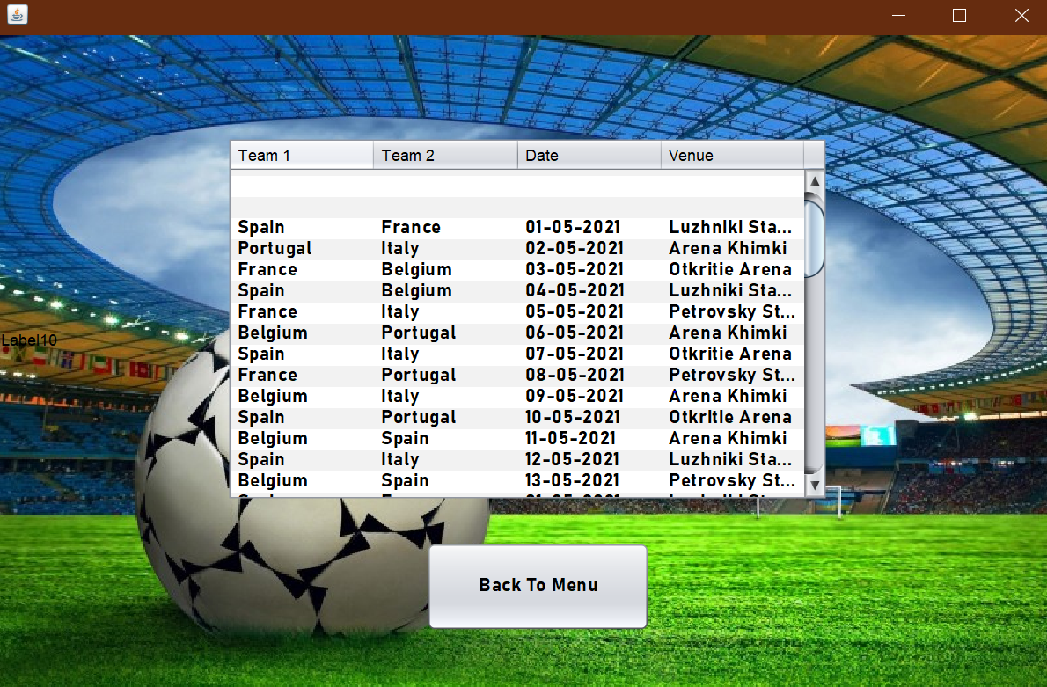

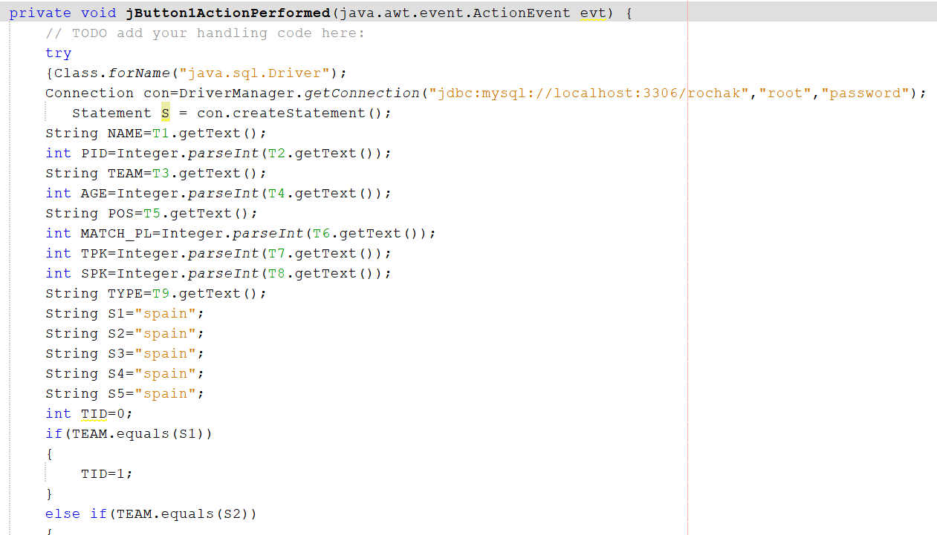**ADD**

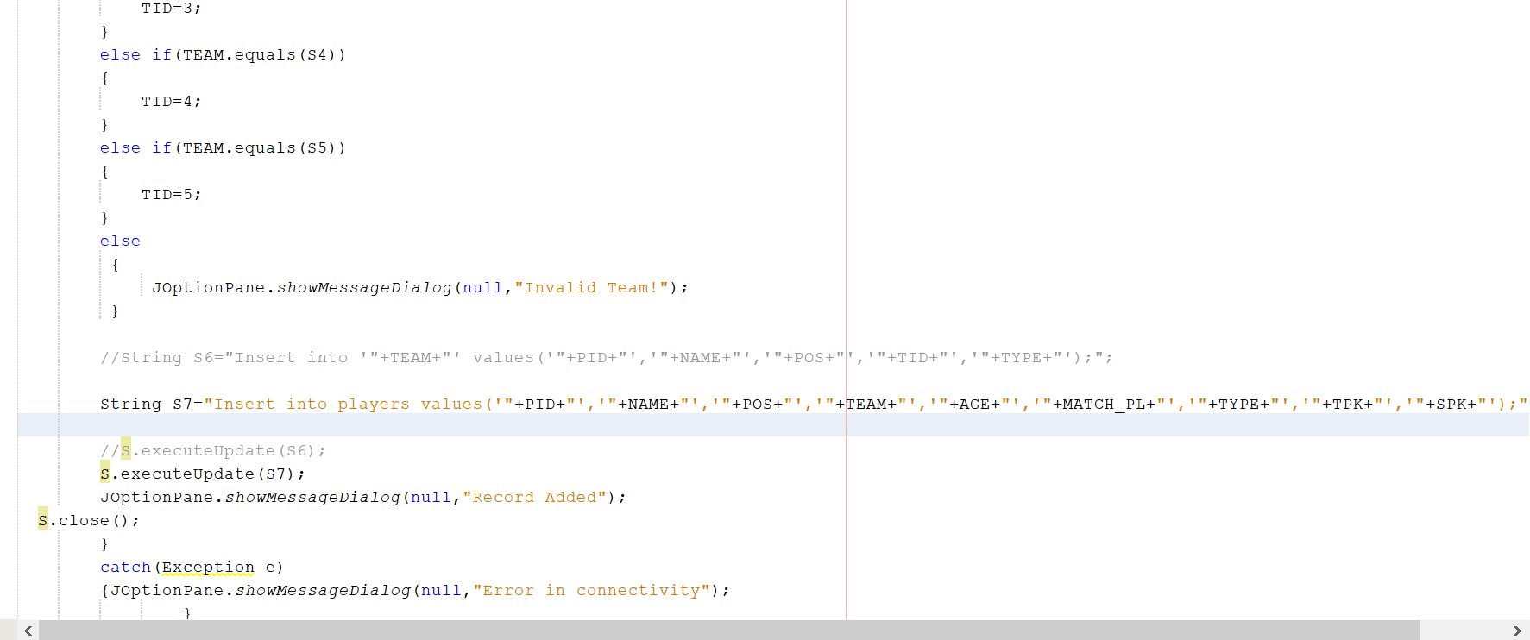

When the frame is opened the above code is executed and frame below is visible. When we enter the records in it and click on add button if adds the record in the players and team name table and a dialogue box is visible.

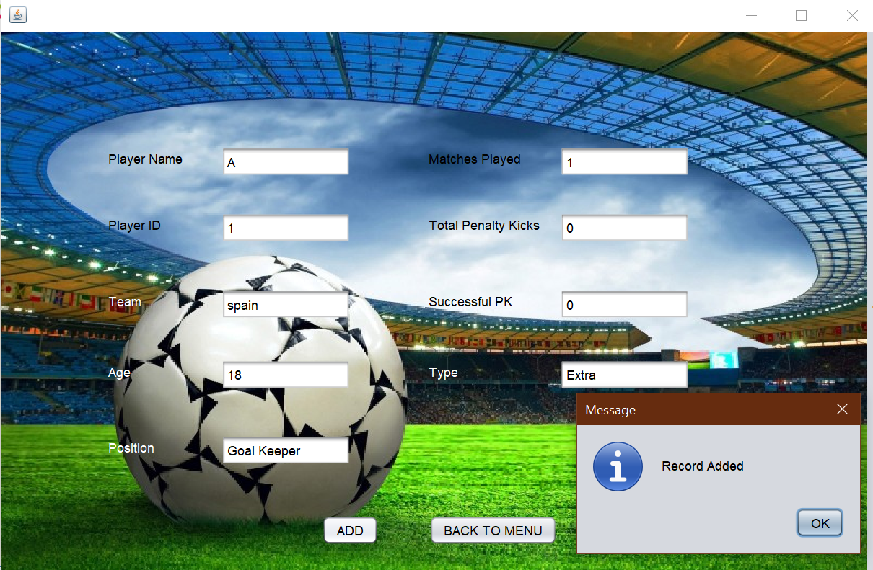

**SEARCH**

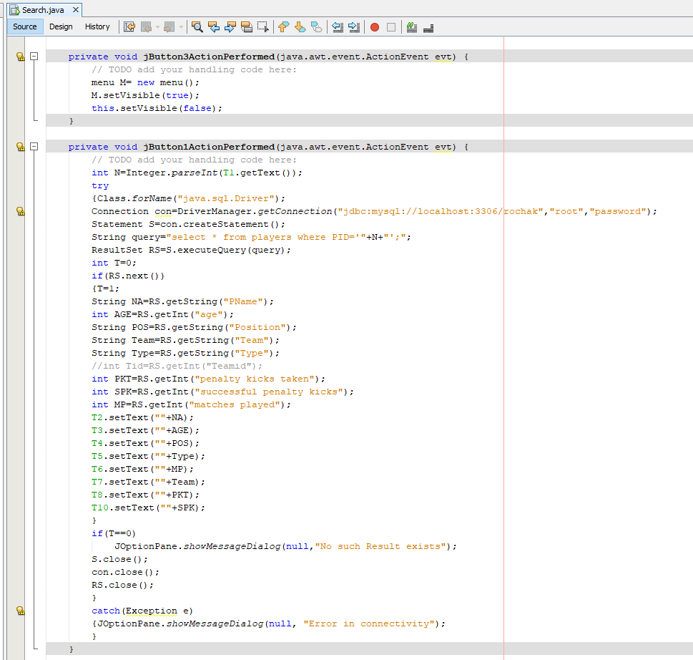

When the frame is opened the above code which is executed which searches for the details of the player for the given playerid and displays it when the search button is pressed.

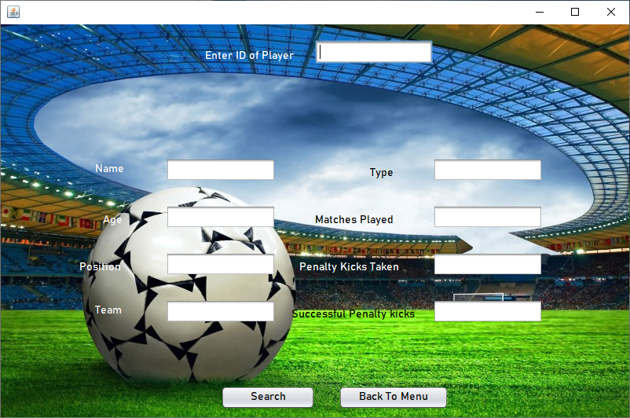

**MODIFY**

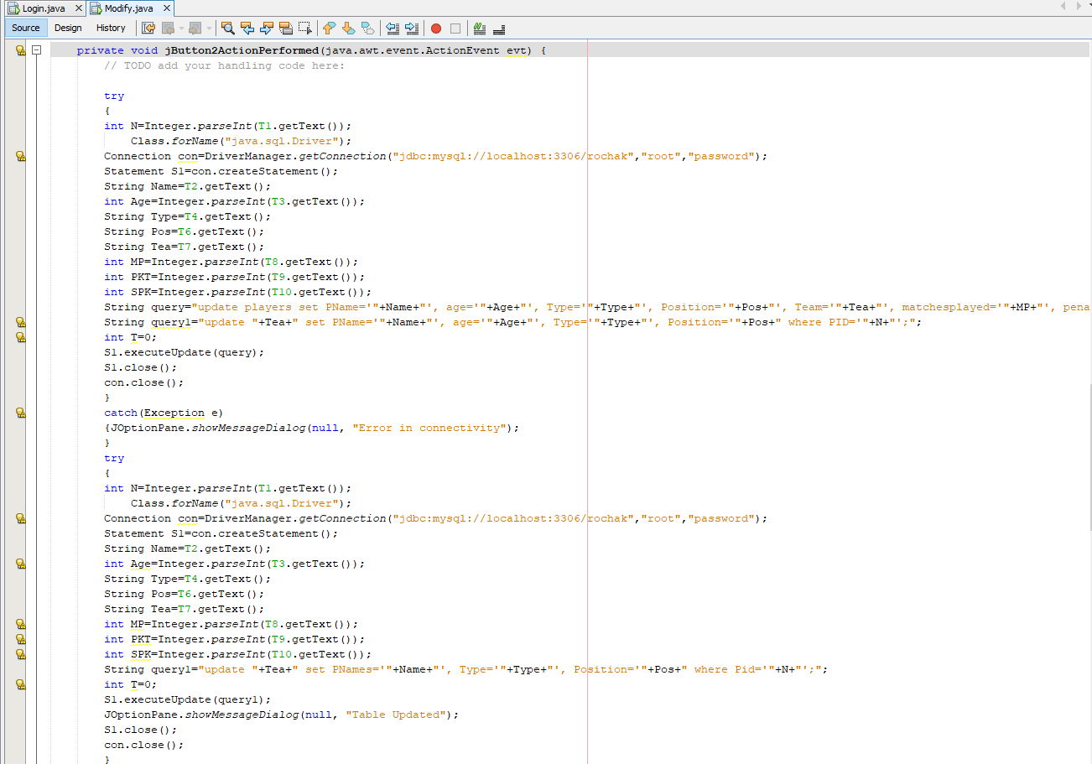

When the frame is opened the above code which first searches for the details of the playerid entered when search button is pressed. Then the user can modify the details which he wants to modify and then click on modify which updates the backend.

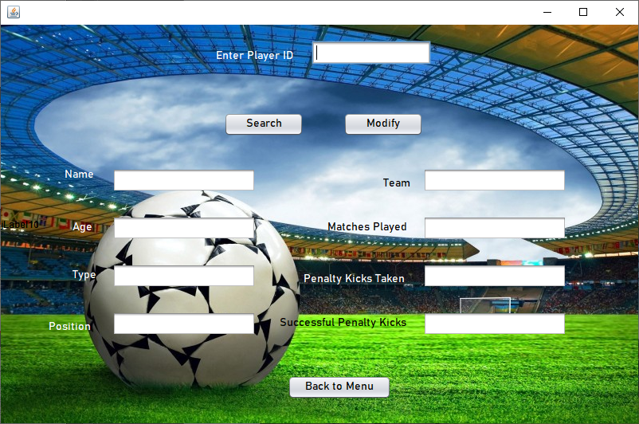

**DELETE**

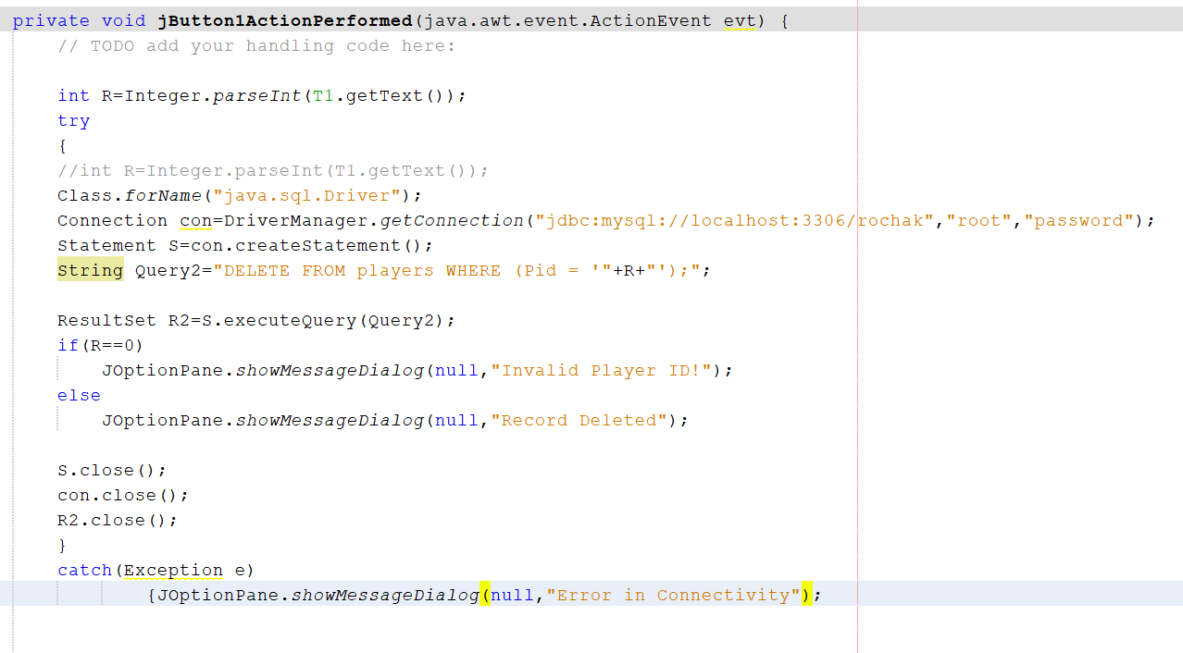

When the frame is opened, the above code is executed and frame below is visible. When we enter the records in it and click on delete button, it deletes the record in the players and team name table and a dialogue box is visible.

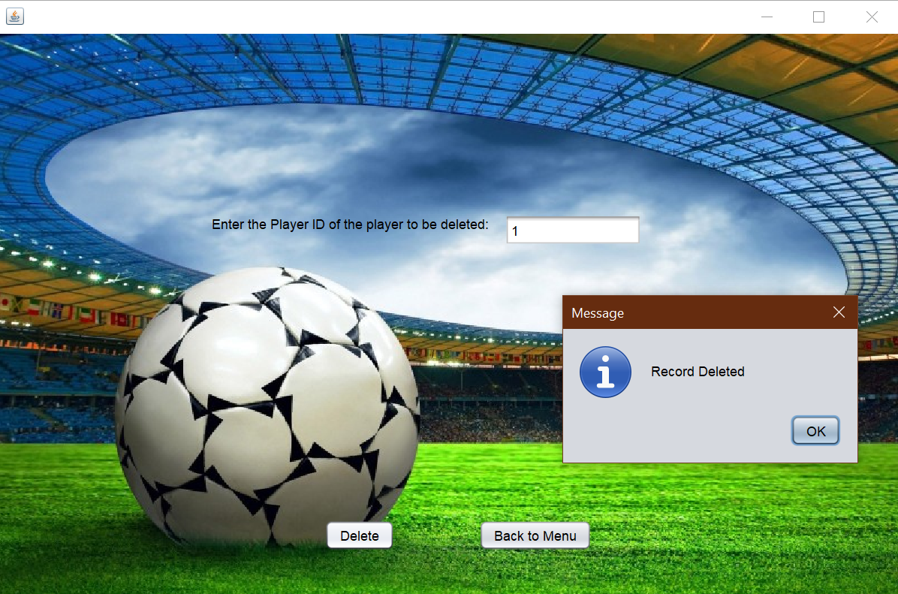

**EXIT**

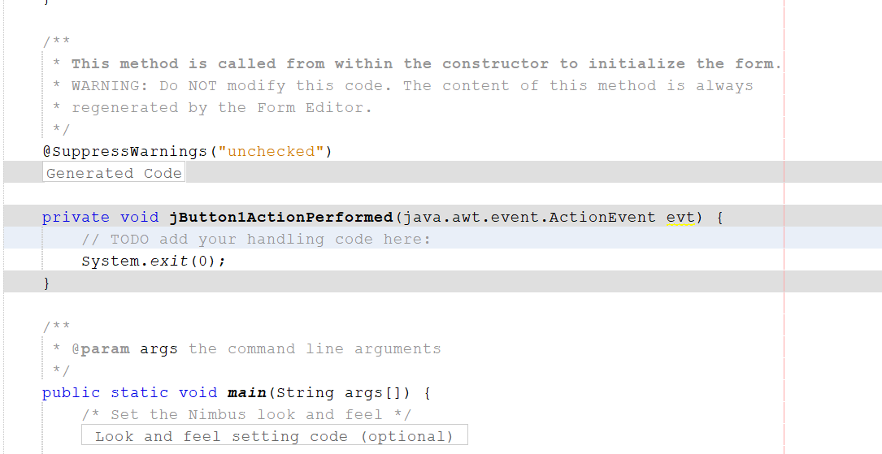

When the frame is opened, the above code is executed when we press exit button and the frame shown below gets closed.

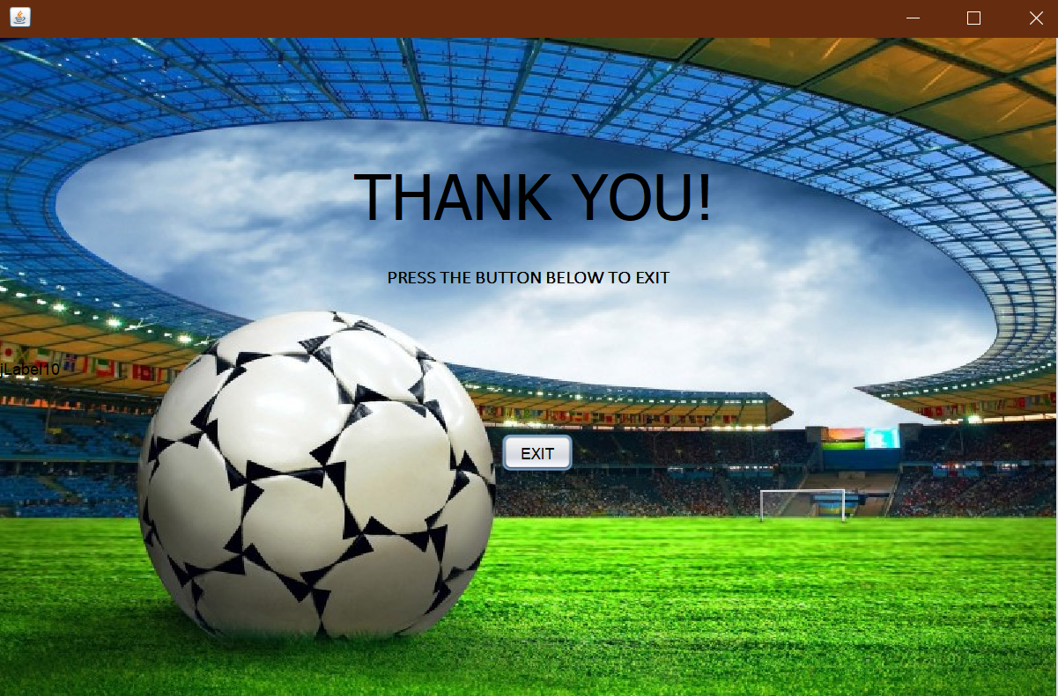

**BACK END:**

Database:

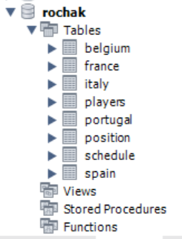

Team France:

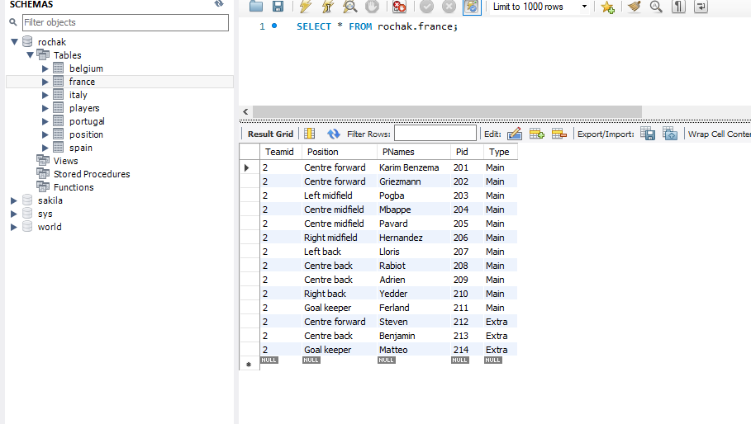

Team Belgium:

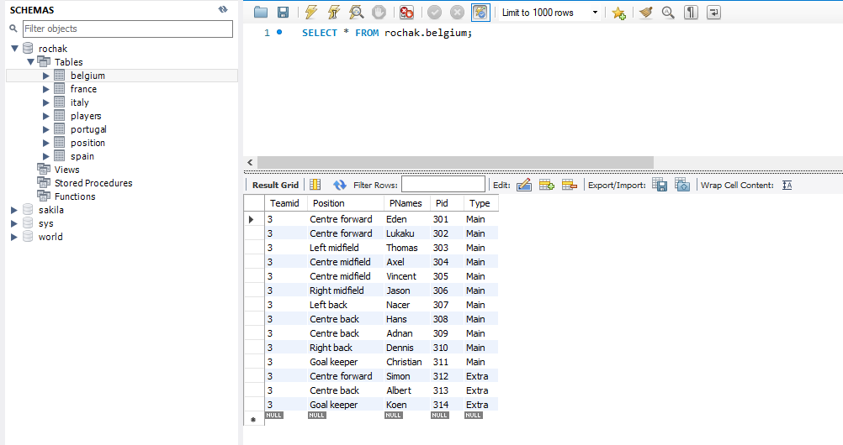

Team Spain:

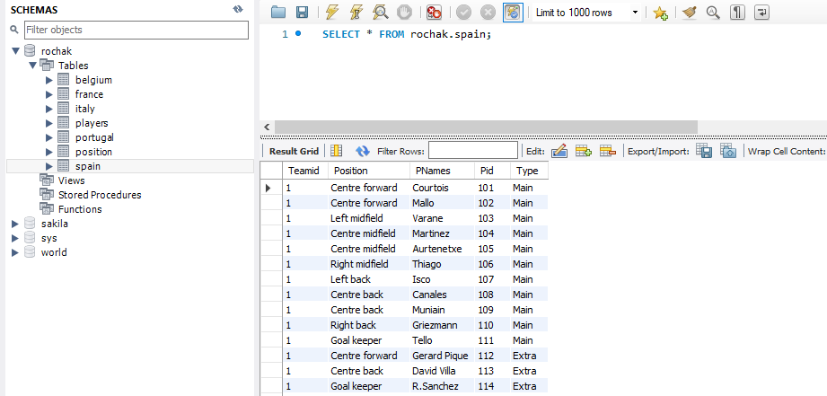

Team Portugal:

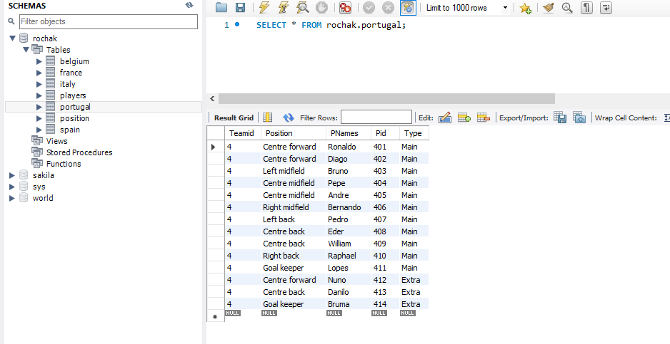

Team Italy:

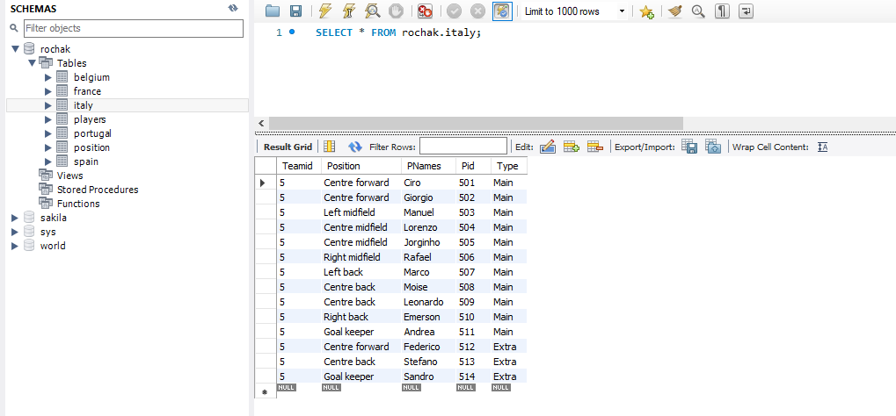

Details of Players:

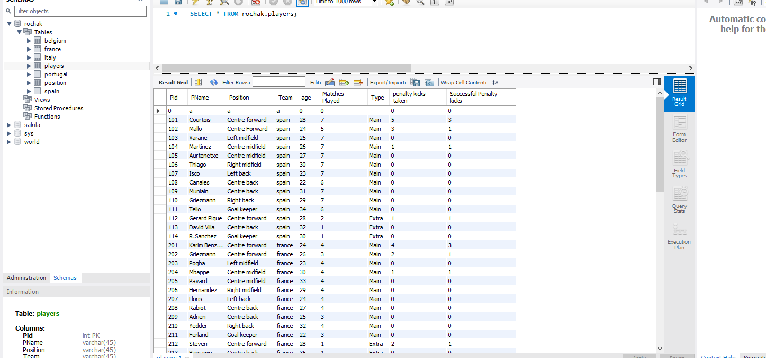

Schedule:

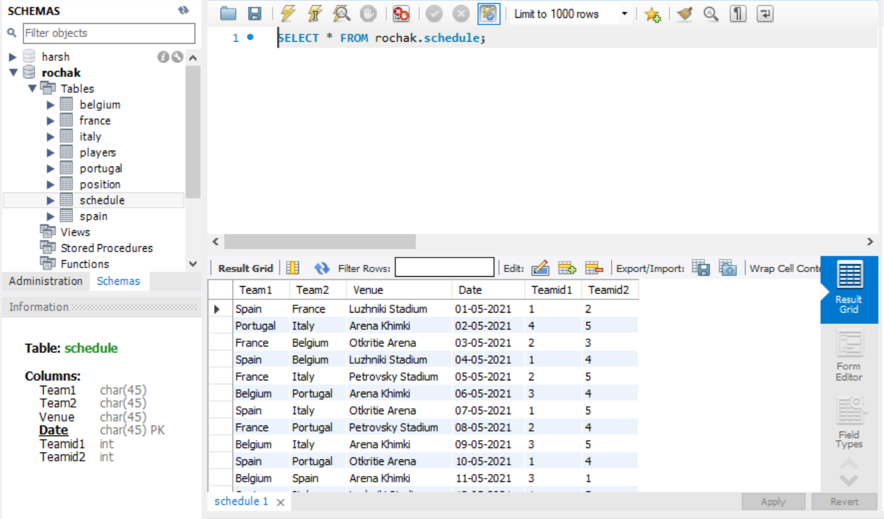

Position:

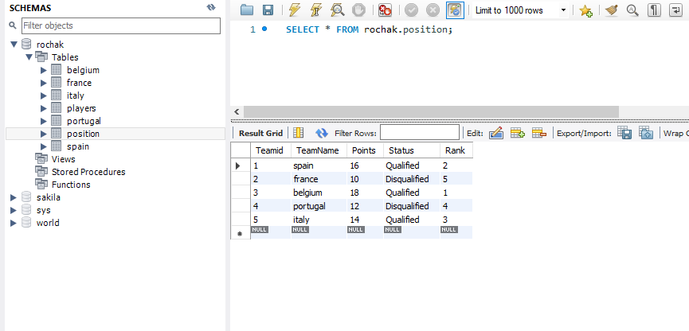

**RESULTS:**

There is a proper functioning of the Football league management system which displays the details of various players, teams, and makes it easy to add more data in it, delete data from it, modify and search the data in a convenient manner also with overcoming disadvantages over file handling system like data redundancy and data inconsistency.

**DATABASE CONNECTIVITY WITH FRONT AND BACK END:**

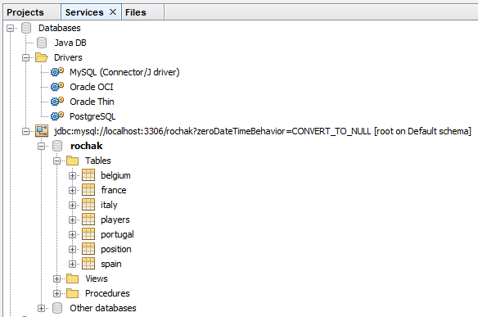



After the creation of different schemas in database Rochak it connected to NetBeans using connector-j-driver-8.0.25 which enables the developer to access backend in his frames using the above given URL in his code though exception handling.

‘Connection con’ statement helps to establish a connection with a system having IP address ‘localhost:3306’, where root is the username for the system ‘rochak’ is the name of the database and ‘password’ is the password for accessing the system.

con.createStatement() method helps in creating a query which later stores the query to be executed.

**SOFTWARES REQUIRED:**

NetBeans IDE: (Front End)

NetBeans is an integrated development environment for Java. NetBeans allows applications to be developed from a set of modular software components.



MySQL: (Back End)

MySQL is an open-source relational database management system. A relational database organizes data into one or more data tables in which data types may be related to each other; these relations help structure the data. SQL is a language programmers use to create, modify and extract data from the relational database, as well as control user access to the database. In addition to relational databases and SQL, an RDBMS like MySQL works with an operating system to implement a relational database in a computer's storage system, manages users, allows for network access and facilitates testing database integrity and creation of backups



**CONCLUSION:**

With the help of this project, we were able to learn a lot of new languages. Working together made us understand every aspect of this project and gain interest in the field of application Development and also taught us about the power of team-work.